CREATION HEALTH  Rest Assured  Discovering Lasting Inner Peace  Mark A. Finley | 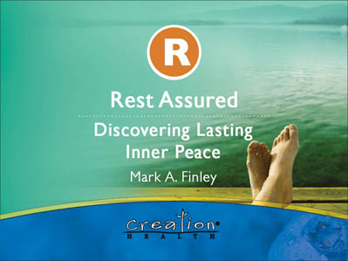  1
Rest is a gift from God that restores our bodies, invigorates our minds and stabilizes our emotions.  It replaces weariness with a new vitality, exhaustion with a new energy and fatigue with a new hope.  Rest is one of our Creator’s laws of health which brings healing for the burned out and broken. | 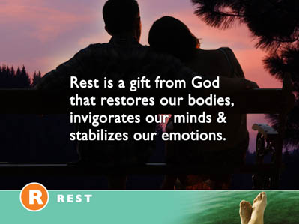  2
A University of California, San Diego psychiatry study of more than one million adults found that people who live the longest report that they sleep for six to seven hours each night. | 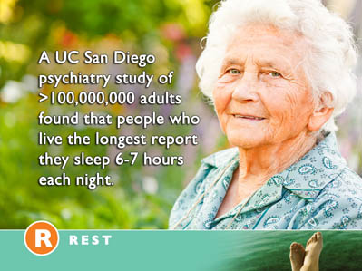  3
Researchers at the University of Warwick and University College London have found that lack of sleep can more than double the risk of death from cardiovascular disease. | 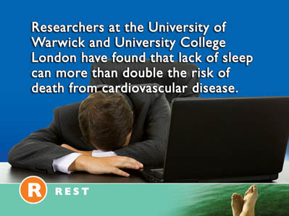  4
Professor Francesco Cappuccio said, "Short sleep has been shown to be a risk factor for weight gain, hypertension, and Type 2 diabetes.” | 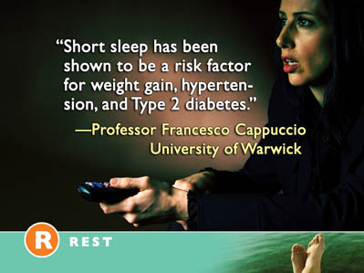  5
Furthermore, sleep difficulties are closely associated with psychiatric disorders such as depression, alcoholism, and bipolar disorder. Up to 90% of adults with depression are found to have sleep difficulties. Sleep deprivation has serious effects on our short term health and multiple long term consequences. It has been associated with irritability, memory loss, impaired moral judgment, type 2 diabetes, increased risk of heart disease, decreased reaction time, muscular aches and pains, tremors, growth suppression, and risk of obesity. | 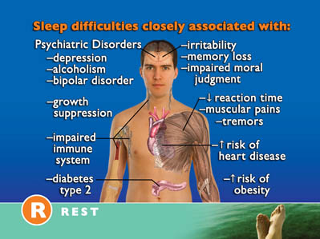  6
SLEEP AND THE IMMUNE SYSTEM  Recent research reveals that sleep deprivation affects the immune system. | 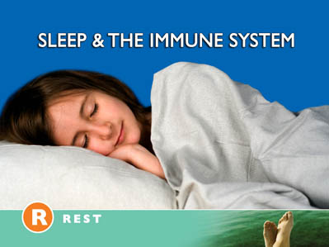  7
In a 2007 study rats were deprived of sleep for 24 hours. When compared with a control group, the sleep-deprived rats' blood tests indicated a 20% decrease in white blood cell count, a significant change in the immune system. | 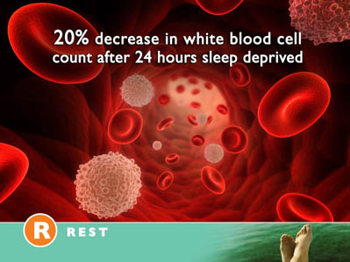  8
It is now possible to state that "Sleep loss impairs immune function and immune challenge alters sleep," and it has been suggested that mammals that invest in longer sleep times are investing in the immune system. | 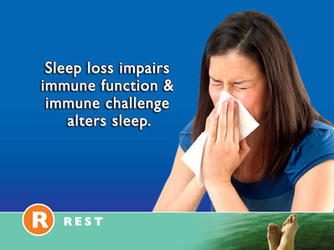  9
Species with the longer sleep times have higher white blood cell counts. This is true up to a point. Some studies indicate that if we sleep over ten hour’s per night longevity decreases. This is probably not related to the fact that people are sleeping so much as it to other physical complications which cause them to sleep so long. | 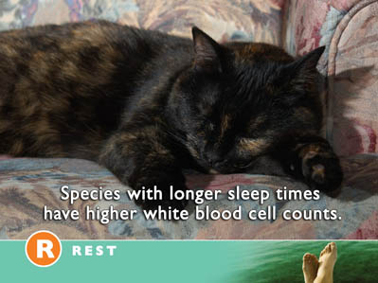  10
STRESS, ANXIETY AND RESTLESSNESS  One of the major causes for a lack of sleep is stress. When the brain is over stimulated and our thought patterns seem to race uncontrollably, restlessness is inevitable. Anxiety, tension and inner worry are one of the primary reasons— | 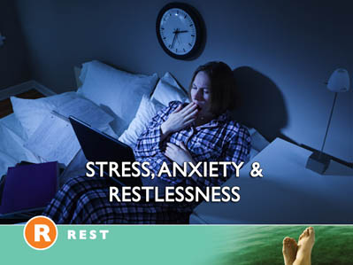  11
More than 40% of all Americans sleep less than six hours per night. | 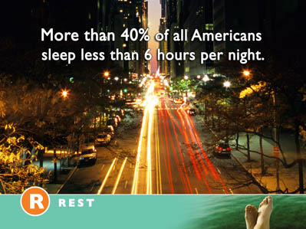  12
As many as one in three are so sleepy during the day that it seriously impairs their performance in the home, at work or at school. If we are going to truly find rest, we will have to discover a way to reduce the stressors which are causing our restlessness. We will have to discover a meaningful way to deal with worry and neutralize the excessive stress which is creating such havoc with our lives. |   13
REST ASSURED IN AN ALL LOVING CREATOR  This leads us to an all important question. What can we learn from recent medical research about dealing with worry, anxiety and tension? Are their any groups of people who seem to handle stress better than others? Do we have any significant coping models? | 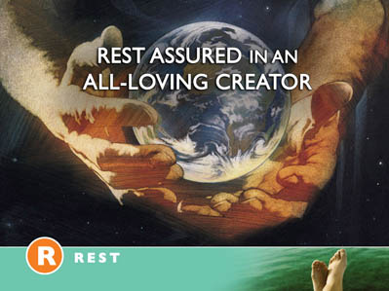  14
Fortunately we do. People who have a strong faith seem to do much better in their overall coping abilities. They are much more positive in their outlook on life and tend  to handle stress better. They tend to be more peaceful, have calmer attitudes and rest better. | 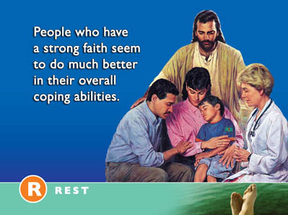  15
Dr. Herbert Benson, a cardiologist at Harvard University, discusses the stress reducing benefits of faith and then comments that faith can, “reduce anxiety and blood pressure.” | 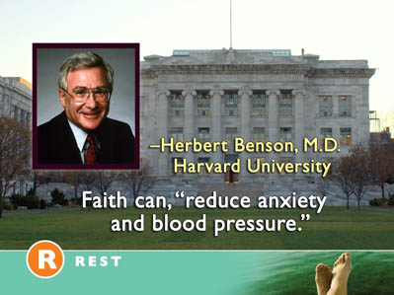  16
In his book, Timeless Healing, Dr. Benson puts it even more strongly, “Our genetic blueprint has made believing in an infinite Absolute part of our nature...We are wired for God.” In other words when we learn to trust God we are living in harmony with the very laws of our being. | 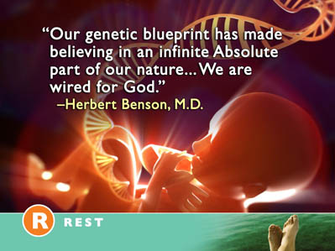  17
As Augustine put it centuries ago, “Lord our hearts will never find rest until they find rest in thee.” | 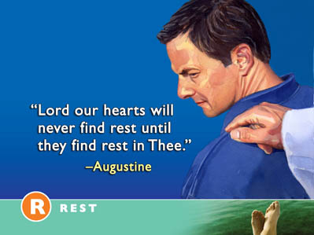  18
Dr, Harold Koenig of Duke University studied the relationship on faith and depression in people over 55. His research was published in the American Journal of Geriatric Psychiatry.  “This research examined the religious characteristics of older medical inpatients with major and minor depression, comparing them to religious characteristics of non-depressed patients and examining their relationship to severity and type of depressive disorder. One thousand (1000) medical inpatients over age 50 at Duke University Medical Center and three community hospitals were identified with depressive disorder using a structured psychiatric interview.” | 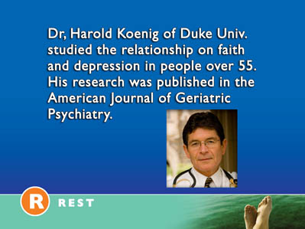  19
The study revealed that, “ Among depressed patients, depression severity was associated with lower religious attendance, less prayer, less scripture reading, and lower intrinsic religiosity. | 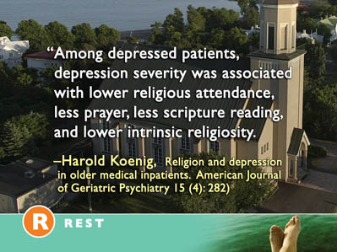  20
In summary, older medically ill hospitalized patients with depression are less religiously involved than non-depressed patients or those with less severe depression.”(Koenig HG (2007). Religion and depression in older medical inpatients. American Journal of Geriatric Psychiatry 15 (4): 282)  We might ask, “Why is faith so powerful in reducing anxiety and promoting a restful mental attitude? And “If faith improves our health how can we increase our faith?” | 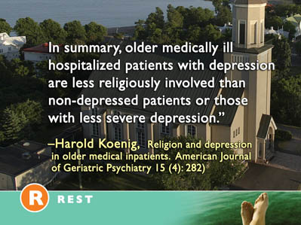  21
Our answer can be found in the very first words of the Bible, “In the beginning, God created the heavens and the earth.”(Genesis 1:1) We are not merely a collection of random cells. We are not simply the product of accidental chance. We are not left alone to face the struggles of life. We are much more than an enlarged protein molecule. | 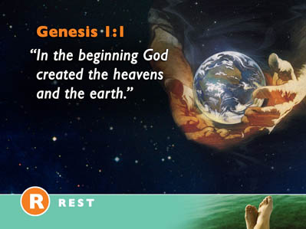  22
We were created in the image of God. (Genesis 1:26) This makes all the difference. The God who created us cares for us. We are not left alone in the universe.  A loving God fashioned us. We can rest in His care. We can rejoice in His love. We can be assured that whatever happens in our lives, He is there to encourage us, strengthen us and support us. | 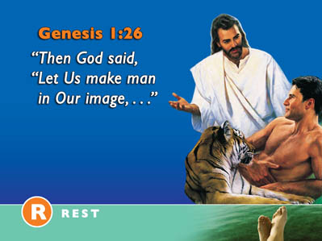  23
We live in a world of good and evil. And at times bad things happen to good people. There may be factors other than our personal choices which greatly impact our health. Natural disasters, war, social upheaval, a failing economy, and genetic factors may all play a part in our total well being. But in spite of the unexplainable things which sometimes happen to us, our loving Creator is there to strengthen us and give us hope. | 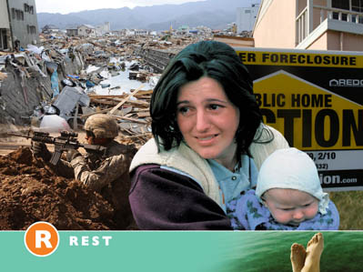  24
The Old Testament prophet Isaiah declared, “Thou wilt keep him in perfect peace whose mind is stayed on You, because He trusts in You. Trust in the Lord forever.”(Isaiah 26:3) | 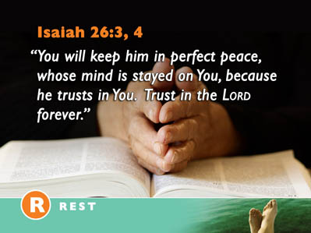  25
The Wiseman Solomon affirms the clear link between trust and our physical and mental health in these words, “Trust in the Lord with all your heart, and lean not on your own understanding; in all you ways acknowledge Him and He shall direct your paths. | 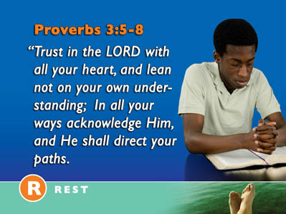  26
Do not be wise in your own eyes; fear the Lord and depart from evil. It will be health to your flesh and strength to your bones.” (Proverbs 3:5-8) | 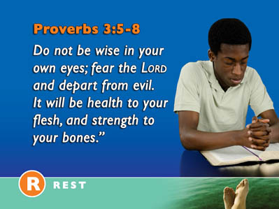  27
The Psalmist admonishes us to, “Rest in the Lord and wait patiently for Him...Cease from anger and do not fret, it only causes harm.”(Psalm 37:7, 8)  Our faith in an all wise Creator enables us to see life from a new perspective. There is a paradigm shift in our thinking. We have the absolute assurance that God is in control of our lives even in the midst of our deepest crisis and that through it all He will draw us closer to Him. We can rest in His care and rejoice in His love even in life’s most challenging moments because we know His ultimate purpose for our lives will be accomplished. | 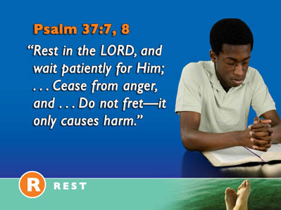  28
David Larsen, the former President of the National Institute for Healthcare Research puts it this way,  “Catastrophic events can bring on so much stress in your life that you end up with illness, so the ability to handle that stress with a world view that reinterprets it in a way that lets you say, ‘God is teaching me through this …’ is beneficial.” | 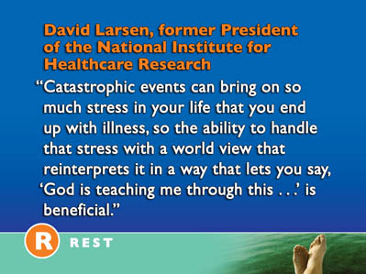  29
What I might view from one side as pain and suffering is from God’s side an opportunity for us to be closer to Him. If the situation is reinterpreted as something where I get to know God in a better way, or as a situation which deepens my spiritual life, that’s taking the cutting edge off the stress.” | 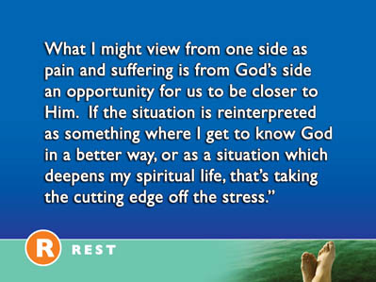  30
Our mental attitudes make an amazing difference in our overall health. A host of scientific studies confirm the truth of Solomon’s statement that, “Anxiety in the heart of man causes depression....” (Proverbs 12:25) | 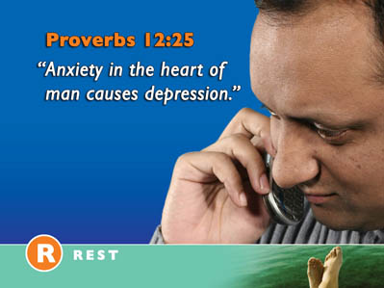  31
This is why the apostle Paul states,  “Be anxious for nothing, but in everything by prayer and supplication, with thanksgiving, let your requests be known to God.”(Philippians 4:6) If we trust God implicitly our mental attitudes will improve and our overall health will benefit. | 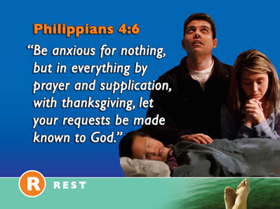  32
Trust does not mean that we will always understand what is happening to us or that we even accept it. | 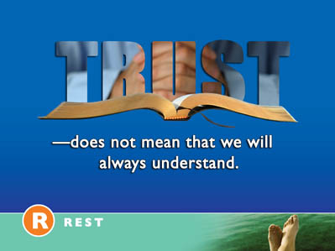  33
Trust does not mean that we will always like what is happening or believe it is fair. | 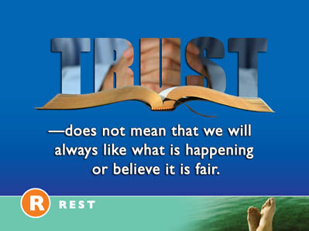  34
Trust does not mean that I think I deserve what is happening to me. | 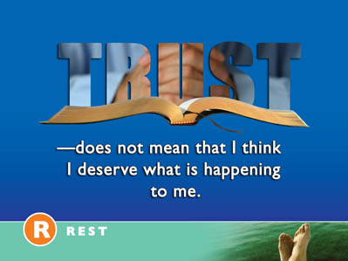  35
It certainly does not mean I believe God caused what I am going through. What then is trust? Why is trust so important if we are going to have inner peace? | 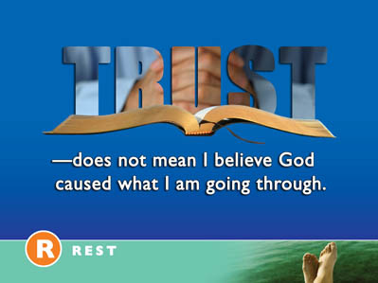  36
Trust is believing God loves me and always desires my best good. | 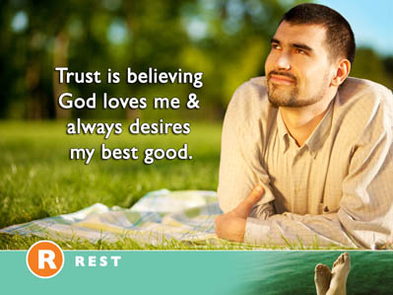  37
Trust is understanding God will cause me to triumph even in life’s most difficult times. | 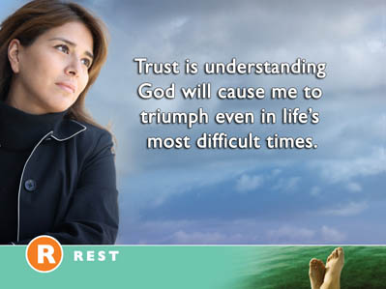  38
Trust is having confidence in God’s care even if I do not understand what I am going through. | 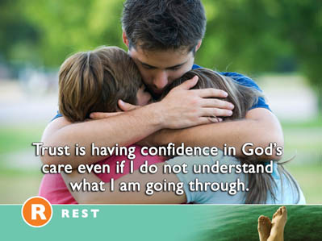  39
Trust is resting in His love and experiencing His peace even in life’s toughest times. | 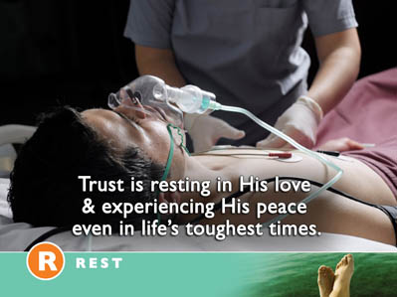  40
Trust is depending on God as my best friend knowing He will never let me down. | 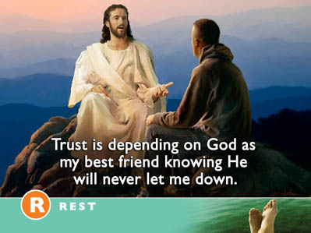  41
A POWERFUL EXAMPLE OF TRUST  Sometime ago I received a letter from a young mother who had lost both of her sons- a three year old and a 16 month old baby boy on a single day. Both had drowned in a freak accident in the family’s backyard swimming pool. After a very difficult period of grief she managed to refocus her vision. She began to quietly meditate on specific passages of scripture. She prayed daily that God would help her to rest in His love. Although she continued to struggle to understand what happened, she asked God to help her to trust Him in spite of the horrible events she had been through.  As she persistently prayed, meditated upon God’s goodness, and studied His Word, a miraculous change took place in her life. | 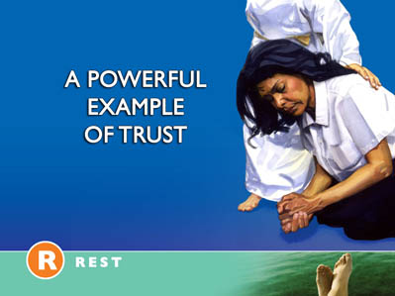  42
In her letter to me, she wrote these amazing words, “Now I hunger and thirst after God because of my love for Him. I know what it means to depend on Him fully, to seek Him with my whole heart, to love Him with my innermost being..... | 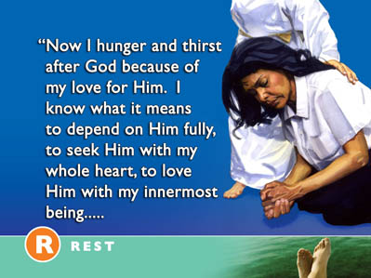  43
I know how it feels When God touches your soul and comforts you. I know how it feels to rest my head His bosom.”  As the result of this deep trust relationship with God, a new peace flooded into her soul. She learned to trust Him in this most difficult time of her life. She was not filled with crippling guilt, or life shattering depression. She learned to rest in God’s love in the face of life’s overwhelming challenges. | 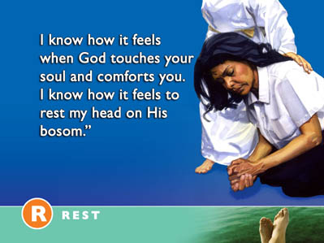  44
Here are three simple steps to increase your faith in God and help you develop a restful spirit and trusting heart that will bring health to your body and mind.  - Daily meditate upon the fact that God loves you and desires you no harm.  Let the apostle Paul’s words sink deeply into your mind. | 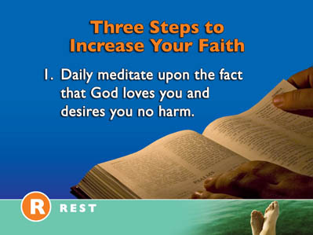  45
“And we know that all things work together for good to those who love God, to those who are called according to His purpose.”(Romans 8:28) Notice Paul does not say that all things are good. There are many things in life that are not good  at all. They bring tears to our eyes and incredible sorrow to our hearts.  By faith we believe that God is greater than our problems and larger than our difficulties. Trusting in Him our hearts are at rest. | 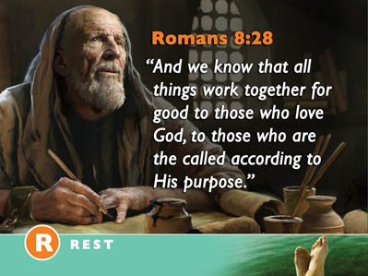  46
2. Consciously surrender your deepest cares to Him. | 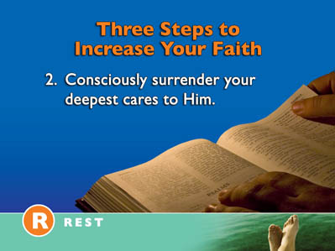  47
The apostle Peter says, “Casting all of your care upon Him for He cares for you.”(1 Peter 5:7) Phillips Translation of the Bible says, “Throw the full weight of your anxiety upon Him.” Think of the things in your life that trouble you most. One by one present them to Him. Be very specific with God. Present the very thing that is robbing you of peace. | 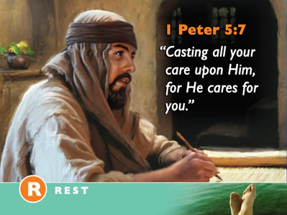  48
3. Believe that He is lifting the burden off your shoulders right now.  Accept the fact that He is giving you rest right now. Claim Jesus promise right now as your own. “Come to Me all you who labor and are heavy laden and I will give you rest.” (Matthew 11:28) Rest is a gift that Jesus freely offers us. As we accept it by faith, our hearts will be at peace. | 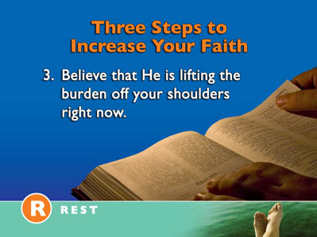  49
THE CREATOR’S TIMECLOCK  There is another aspect of resting in our Creator’s loving care that we must not miss if our hearts and minds are going to be at rest. | 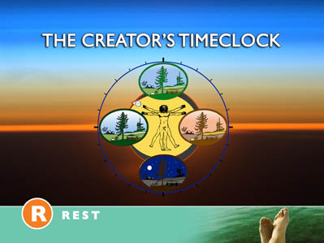  50
The relatively new science of chronobiology has uncovered some totally unexpected facts about living things, as Susan Perry and Jim Dawson report in their book The Secrets Our Body Clock Reveal. "Weekly rhythms -- known in chronobiology as "circaseptan rhythms" -- are one of the most puzzling and fascinating findings of chronobiology. Circaseptan literally means "About seven.” Daily and seasonal cycles appear to be connected to the moon. But what is there in nature that would have caused weekly rhythms to evolve? | 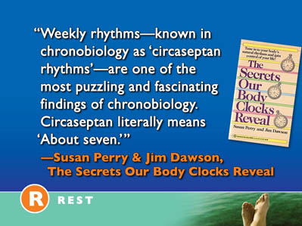  51
"At first glance, it might seem that weekly rhythms developed in response to the seven-day week imposed by human culture thousands of years ago. However, this theory doesn't hold once you realize that plants, insects, and animals other than humans also have weekly cycles. . . . | 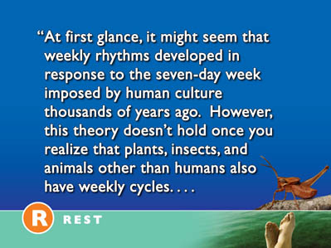  52
Biology, therefore, not culture, is probably at the source of our seven-day week." | 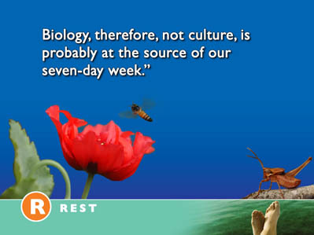  53
Campbell summarizes the findings of the world's foremost authority on rhythms and the pioneer of the science of chronobiology: "Franz Halberg proposes that body rhythms of about seven days, far from being passively driven by the social cycle of the calendar week, are innate, autonomous, and perhaps the reason why the calendar week arose in the first place." | 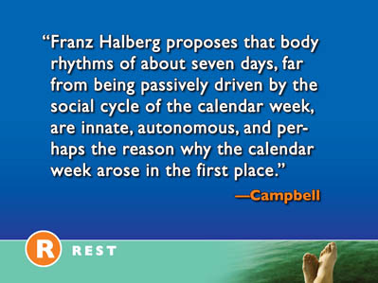  54
In other words built into the very fabric of our beings is a seven-day cycle. Our body’s biological rhythms function in seven day cycles. Healing often occurs in a seven-day cycle. Our energy is renewed in a seven-day cycle. Our minds are renewed in a seven-day cycle. Here are a few fascinating medical facts about these seven day Circaseptan rhythms. | 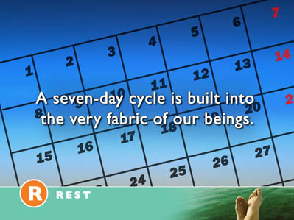  55
Here are a few fascinating medical facts about our bodies seven-day rhythms. Each of the following tends to follow a seven day cycle.  - Rejection of organ transplants.  - Immune system response to infection.  - Blood and Urine chemicals  - Blood Pressure  - Heartbeat  - Common Cold  - Coping Hormones | 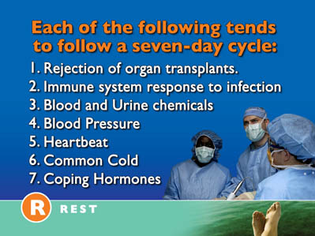  56
The most intriguing of all biological rhythms are those set to a clock of about seven days. In his chapter "The Importance of Time," Jeremy Campbell reports:  "These circaseptan, or about weekly, rhythms are one of the major surprises turned up by modern chronobiology. Fifteen years ago, few scientists would have expected that seven-day biological cycles would prove to be so widespread and so long established in the living world. | 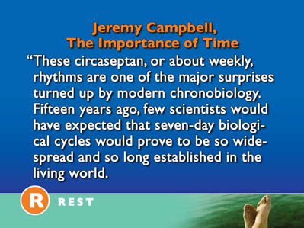  57
They are of very ancient origin, appearing in primitive one-celled organisms, and are thought to be present even in bacteria, the simplest form of life now existing." | 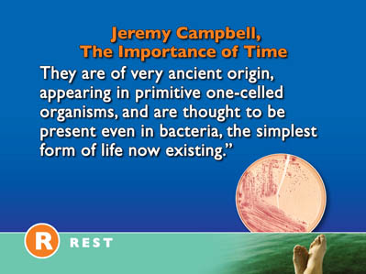  58
This cycle of seven is revealed in the weekly cycle. Each of our measurements of time has an astronomical basis accept the week. The year of course is the amount of time the earth revolves around the sun. | 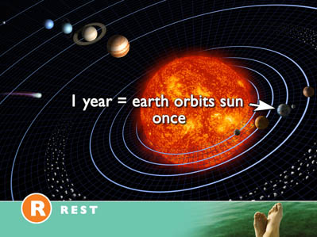  59
The month is the amount of time it takes for moon to orbit the earth. | 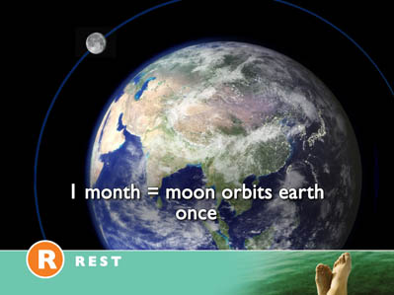  60
And the day is the amount of time it takes for the earth to make one full revolution on its axis. | 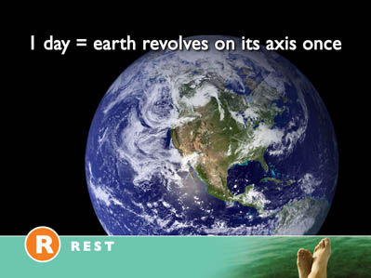  61
What about the week? Where does it come from? Why is this weekly cycle of seven so significant for our health? | 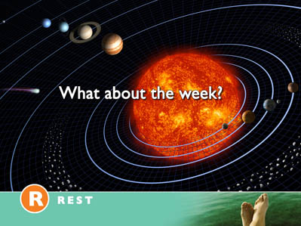  62
Our loving Creator has built into the structure of our beings a biological time clock.  At the conclusion of Creation Week the book of Genesis declares, | 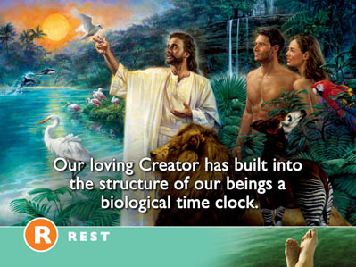  63
“ And on the seventh day God ended the work which He had done, and He rested on the Seventh day from all His work which He had done. | 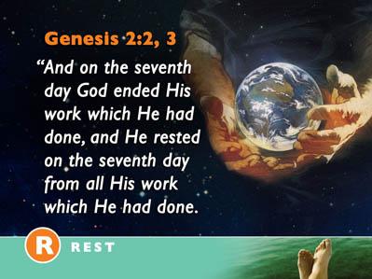  64
Then God blessed the Seventh day and sanctified it, because in it He rested from all His work which He had done.” (Genesis 2:2,3) | 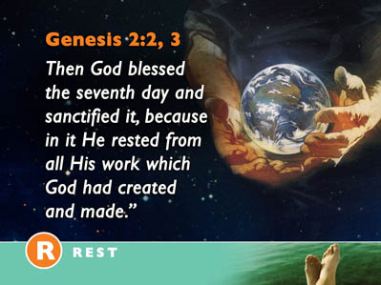  65
The seventh day Sabbath is a day for healing. Resting on Sabbath allows our minds and bodies to be renewed. Spending time together with our families strengthens our relationships. Most of all the Sabbath provides a weekly opportunity to receive inner strength to face life’s challenges. As we draw strength from worshipping our Creator our spiritual life is renewed. Sabbath rest is a refreshing, renewing rest. |   66
To ignore this Sabbath rest and rush frantically through life pushing ourselves to achieve more and get more destroys our health and fractures our relationships. The cycle of life that the Creator has indelibly written on every nerve and tissue of our bodies cries out for renewal every seven days. The Sabbath is not simply a Jewish ritual; it is a loving command by a Creator God who cares incredibly about our total well being. Resting and worshipping on Sabbath places in harmony with the laws of the Universe.  Both the French and Russian atheistic regimes discovered all too quickly that tampering with the seven day weekly cycle negatively affected all society. |   67
French Revolution and Stalin’s Russia  Because of the bond between religion (Christianity especially) and the week, there have been two major attempts in modern times to obliterate the seven-day week in favor of a different length week. | 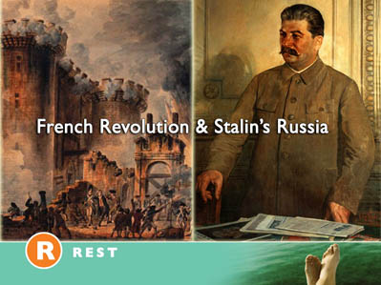  68
The first attempt came in the late 1700s. The humanistic French Revolution promised the people a new Age of Reason to replace regressive religious superstitions. | 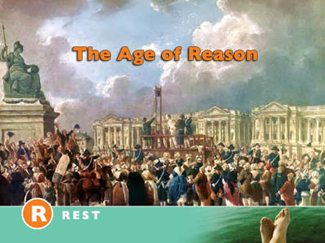  69
A new secular, "rational" week of ten days was devised and approved by the ruling Convention in October, 1793. The ten-day "decade" was patterned after the decimal principle, having ten days divided into ten hours, of 100 minutes each with each minute divided into l00 decimal seconds. Every tenth day was reserved for rest and celebration of various natural objects and abstract ideas. | 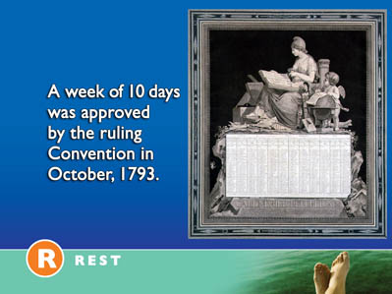  70
Notre Dame Cathedral was renamed the Temple of Reason.  The French quickly abandoned this idea of the ten day week a few years later. Society never seemed to function well at all. Chaos reigned. Work productivity fell. People were exhausted and their health tended to break down more rapidly. The peace and harmony that the atheistic French Revolutionaries promised never materialized. | 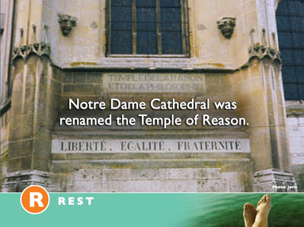  71
We were made to work six days and rest and worship the seventh. Our Creator knows best. After all He made us. |   72
The Russians failed to learn their lessons from the French.  Not learning a thing from France's failure, the Communists ruling the Russian Revolution tried a second, even more radical experiment 140 years later. Their aim was the same: abolish religion by abolishing the seven-day week. |   73
The Soviet scene was a five-day continuous work week which called for 80 percent of workers to be on the job on any given day -- a plan which left 20 percent to share a day off. There was no longer a national day off. The advertised reason for the new rotating five-day week was to increase production. | 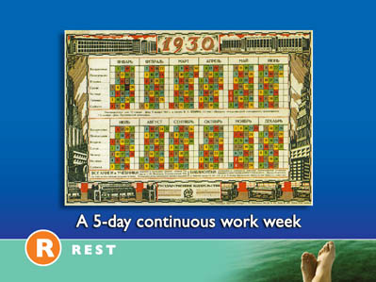  74
After eleven years of disappointing production and epidemic irresponsibility in the work place (1929-1940) Stalin called it quits and gave the Soviet people back their seven-day week.  In both France and the Soviet Union, desperate attempts were made by two of the most ruthless totalitarian regimes in history to completely destroy the Judeo-Christian, seven-day week. In both societies, the experiment tragically failed. | 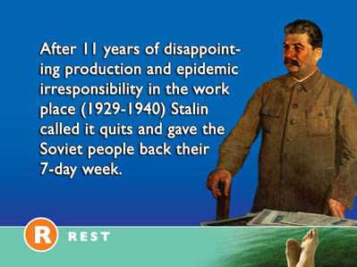  75
We are worshipping beings. We were made to find our rest in the arms of our loving Creator. To ignore Him is to turn our backs on the rest He offers. Freedom from health destroying anxiety comes from knowing Him. Deliverance from crippling fear comes from trusting in His goodness. Liberation from the bondage of guilt comes from resting in His forgiveness and peace. | 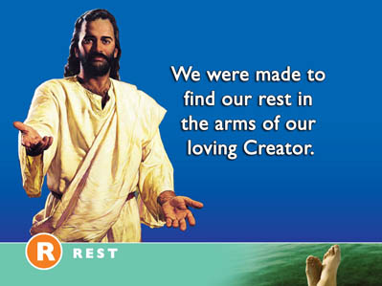  76
IT IS WELL WITH MY SOUL  There is a peace that comes from being secure in God’s love. The circumstances of life may overwhelm us but our hearts can still rest in His goodness. The challenges of life may loom large but we can still experience a “peace” which passes all human understanding. Our troubled hearts can find rest in Him. The one hymn which illustrates this fact as well as any other is the well known song, “It Is Well with my Soul” written by Horatio Spafford. This hymn was written after several traumatic events in Spafford’s life. The first was the death of his only son in 1871 at the age of four, shortly followed by the great Chicago Fire which ruined him financially. He had been a successful Chicago lawyer. The fire completely destroyed his multiple business holdings. Then in 1873, he had planned to travel to Europe with his family on the SS Ville du Havre, but sent the family ahead while he was delayed on business concerning zoning problems following the Great Chicago Fire. While crossing the Atlantic, the ship sank rapidly after a collision with an English sailing ship, the Loch Earn, and all four of Spafford's daughters died. His wife Anna survived and sent him the now famous telegram, | 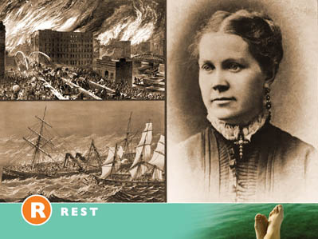  77
"Saved alone." Shortly afterwards, as Spafford traveled to meet his grieving wife, he was inspired to write these words as his ship passed near where his daughters had died. | 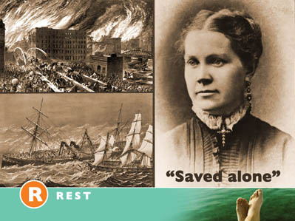  78
It Is Well With My Soul  When peace like a river, attendeth my way,  When sorrows like sea billows roll;  Whatever my lot, Thou hast taught me to know,  It is well, it is well, with my soul.  Refrain:  It is well, with my soul,  It is well, with my soul,  It is well, it is well, with my soul. | 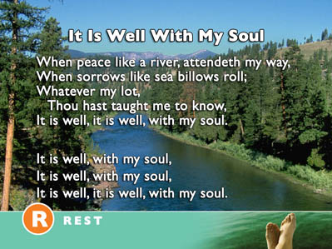  79
Though Satan should buffet, though trials should come,  Let this blest assurance control,  That Christ has regarded my helpless estate,  And hath shed His own blood for my soul. | 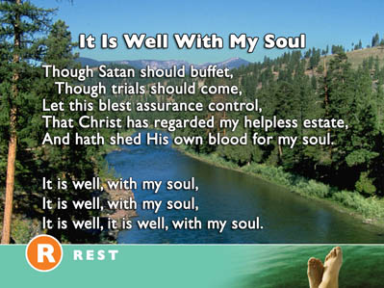  80
But Lord, 'tis for Thee, for Thy coming we wait,  The sky, not the grave, is our goal;  Oh, trump of the angel! Oh, voice of the Lord!  Blessed hope, blessed rest of my soul. | 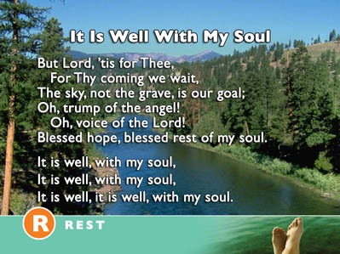  81
And Lord, haste the day when my faith shall be sight,  The clouds be rolled back as a scroll;  The trump shall resound, and the Lord shall descend,  Even so, it is well with my soul.  Horatio Spafford | 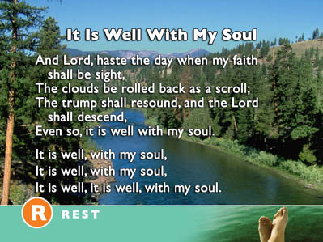  82
Would you like to have this unshakeable inner peace?  Would you like a peaceful heart and a calm spirit which are not dependant on the changing circumstances of your life? This peace can be yours as you learn to trust completely in the Peacemaker. Jesus, the Prince of peace, offers you His peace right now. It is a gift of His love to you. As you quietly ask Him to take complete control of your life and accept the assurance that only He can give a new peace will replace your worries, fears and anxieties. You can rest confidently in His love knowing for certain that He cares for you and will never forsake you. Peace is the result of knowing the Source of all peace. Millions have found a deep, lasting peace in Him. Why not pray this simple prayer right now. | 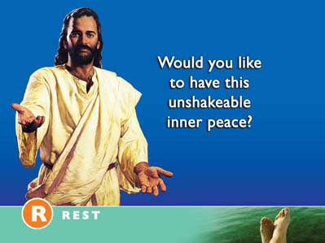  83
“Dear Lord, often my heart is restless. Worry clouds my mind and discourages my heart but just now I look you as the source of my peace and accept the rest that you offer right now. I willingly surrender to you my worries and fears and choose to receive you peace and rest right now. Thank you for giving to me your peace. In Jesus name. Amen.” | 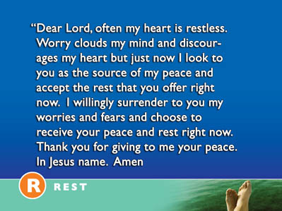  84

