WHAT DIFFERENCE DOES FAITH MAKE? | 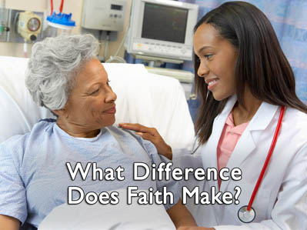  1
CREATION HEALTH  Mark A. Finley  THE HEALING POWER OF FAITH  For the last twenty five years researches have been examining the relationship between faith and health or spirituality and religion more closely. | 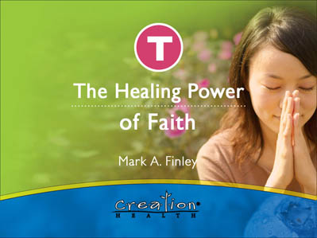  2
I was first sensitized to the subject a number of years ago when I was flying across the country accompanying my teenage son back to college. As he sat next to me on the plane reading the USA Today, he nudged me and said, “Dad you really need to read this article.”  The front page USA Today article was on prayer and healing. It opened my eyes to some of the research being done on the relationship between faith and health. Since that time I have been amazed at the ever increasing evidence. |   3
Faith makes a positive difference in our physical, mental and emotional health. Although the research is continuing and we do not have all the answers we know enough to know that faith matters. |   4
Well known universities, national public health research institutions, and privately funded health organizations are all coming to similar conclusions. A strong belief system can be a foundation for improved health.  Here is a sampling, according to some researchers, of what a dose of spirituality can do for you. | 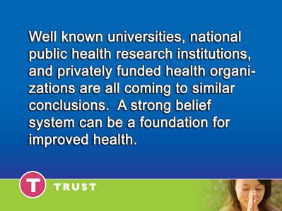  5
STRESS  A comprehensive study conducted in Alameda County, California followed the lifestyle practices of nearly 7,000 Californians. It revealed that West Coast worshippers who participate | 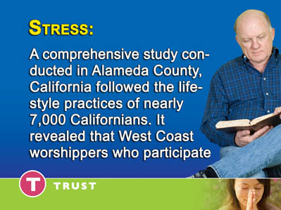  6
in church-sponsored activities are markedly less stressed over finances, health and other daily concerns than non-spiritual types (Journal of Gerontology: Psychological Sciences, 1998). | 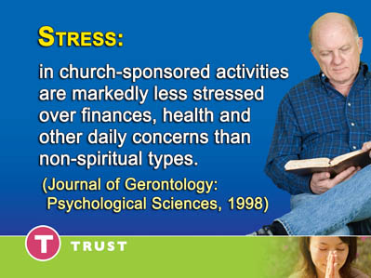  7
BLOOD PRESSURE  Senior citizens in a Duke University study who attended religious services, prayed or read the Bible regularly, had lower blood pressure than those who did not pray or study the Bible. (International Journal of Psychiatry in Medicine, 1998 | 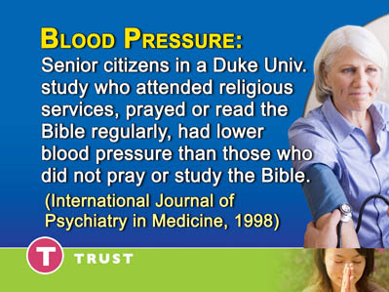  8
RECOVERY  In a Duke University study, devout patients recovering from surgery spent an average of 11 days in the hospital compared with nonreligious patients who spent 25 days (Southern Medical Journal, 1998). | 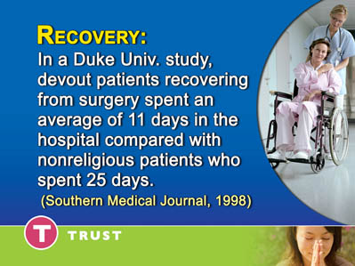  9
MORTALITY  Research on 1,931 older adults indicates that those who attend religious services regularly have a lower mortality rate. (American Journal of Public Health, 1998). | 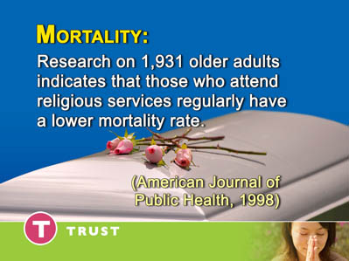  10
IMMUNITY  Research on 1,700 adults found that those who attend religious services were less likely to have elevated levels of interleukin-6, an immune substance prevalent in people with chronic diseases (International Journal of Psychiatry in Medicine, 1997). | 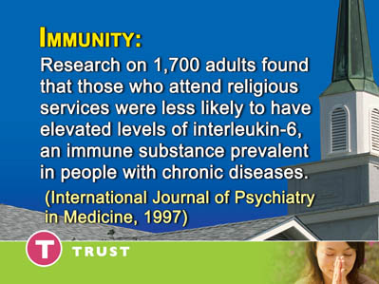  11
LIFESTYLE  A recent review of several studies suggests that spirituality is linked with low suicide rates, less alcohol and drug abuse, less criminal behavior, fewer divorces and higher marital satisfaction. (Religion and Clinical Practice, 1996) |   12
DEPRESSION  Women with pious moms are 60% less likely to be depressed in 10 years than women whose mothers aren't so reverent, according to a Columbia University study. | 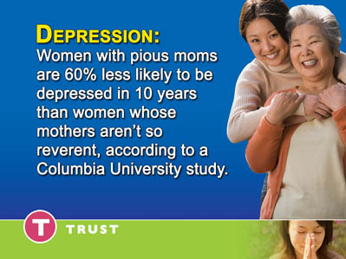  13
Daughters belonging to the same religious denomination as their mothers are even less likely (71%) to suffer the blues; sons were 84% less likely (Journal of the American Academy of Child and Adolescent Psychiatry, 1997). | 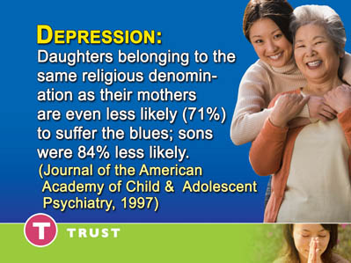  14
Hospitalization  A Duke University study of 577 men and women hospitalized for physical illness showed that the more patients used positive religious coping strategies (seeking spiritual support from friends and religious leaders, | 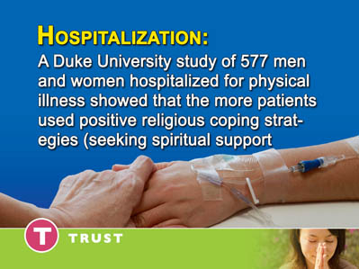  15
having faith in God, praying), the lower the level of their depressive symptoms and their quality of life (Journal of Mental and Nervous Disorders, 1998). | 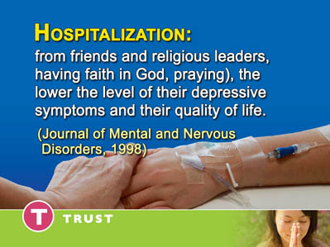  16
FAITH MAKES A DIFFERENCE  The evidence is mounting. The Research is convincing. Faith makes a difference in our physical as well as our spiritual lives. But significant questions still remain. What relationship does faith play to obedience to the laws of health? If we have enough faith can we live as we please and still be healthy? Does faith give us license to violate the laws of health and expect to be healthy?  Bottom of Form  Top of Form  Hand ScheduledSection FocusIn the early 1970’s my wife and I lived in North Georgia. I was the pastor of two small churches and taught Bible at a Medical Missionary Training Institute.. Often we traveled on dirt roads to mountain log homes to study the Bible with families. |   17
One day we were sitting at the table in one of these log cabin homes with a dirt floor and no electricity or running water, back in the Georgia hills, sharing God’s word. The cabin door opened.  A man smoking a big cigar excitedly opened the cabin door and rushed in. With a booming voice he announced to all of us, |   18
“Praise the Lord, I’m healed.” He repeated it. “Praise God, I am healed.” He then went on to explain that on his previous visit to the doctor six months ago he was informed that he had lung cancer. He had just returned from a second visit and his doctor couldn’t find a trace of cancer. “Praise God”, he said,” I’m healed. I couldn’t stand it any longer so I just kind of blurted out, but “what about your big cigar?”  His response.  “No problem when God heals you, He does it completely”  You can smoke cigars as long as you want.”  All you need is faith, that’s all that counts.”  Do you agree with the ‘big cigar’ man?  If smoking cigars causes cancer and you have enough faith  Can you go right on smoking and your faith will counteract the toxic cancer producing effects of the cigar.  Most of us would agree that God is not going to heal us of something that causes cancer so we can do the same thing all over again no matter how much faith we have. This leads us to some basic questions regarding faith. | 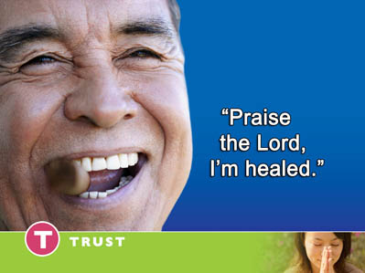  19
QUESTIONS REGARDING FAITH  - What is faith?  - How does faith work? | 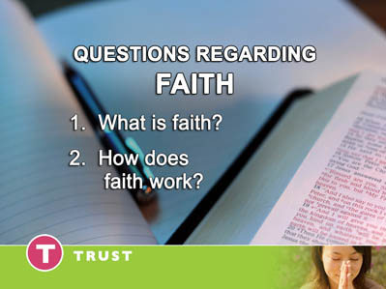  20
- Why does faith seem to work wonders for some people and accomplish little for others? | 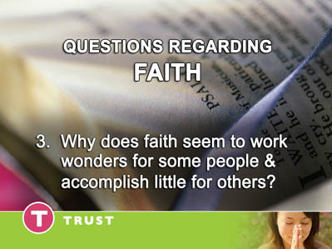  21
- Is faith some sort of a good luck charm that gets us whatever we want? | 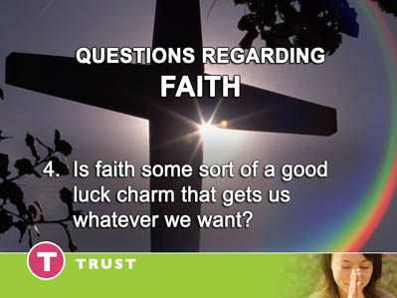  22
- Is faith some kind of divine ‘rabbits foot’ or ‘four leaf clover’ that if I just name it and claim it, I will get it? | 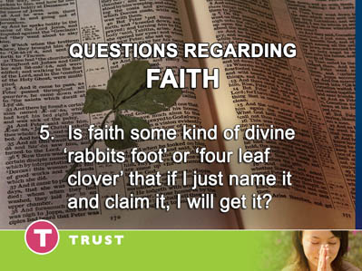  23
- Is faith some kind of hyped up – psyched up – jacked up – positive thinking?  Evidently authentic faith, Biblical faith will be in short supply just before the return of our Lord. | 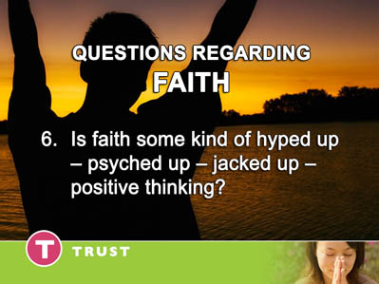  24
Jesus asks this all important question, “Nevertheless, when the Son of Man comes, will He really find faith on the earth?” (Luke 18:8) Why is genuine faith so scarce? What is it and how can we grow our faith? | 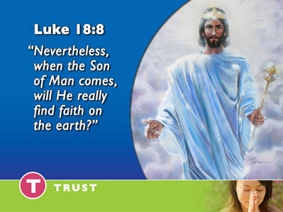  25
LET’S LOOK AT HEBREWS 11  WHAT DIFFERENCE DOES FAITH MAKE IN OUR LIVES?  Hebrews 11 clarifies some of life’s most fundamental questions.  It answers some of life’s deepest issues. It cuts to the heart of the essence of how to live our lives  Let’s explore genuine Biblical faith together. We will study what faith is and what faith is not. We will also consider the source of faith and the result of faith. | 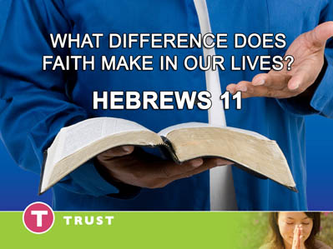  26
To understand the meaning of faith we will look at Hebrews 11:1 “Now faith is the substance of things hoped for, the evidence things not seen.” | 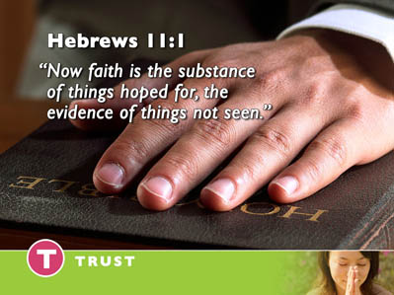  27
What is faith? It is the substance - The Latin word substance comes from two words “sub” and “stance”. | 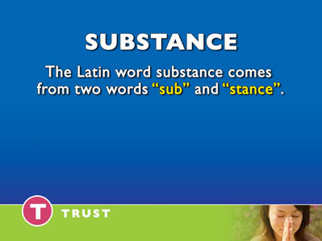  28
“Sub” means “under” of course. We have words like ‘sub marine’ – a boat which travels under the sea | 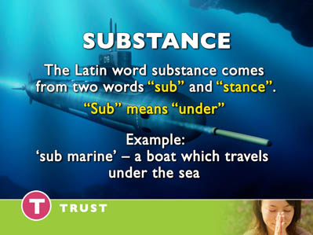  29
And ‘sub – terranean – something under the earth. | 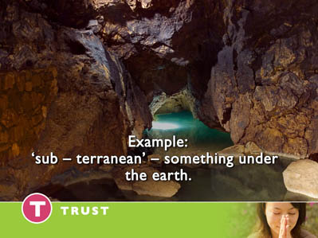  30
The word “stance” refers to the essence of a thing. The substance is the thing that stands under everything else in your life supporting, sustaining and securing it. | 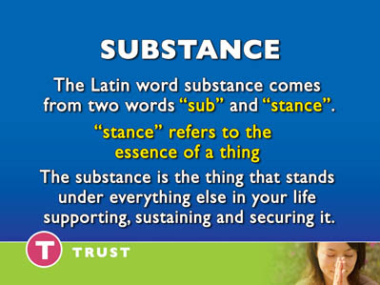  31
Faith is the very foundation of our lives. | 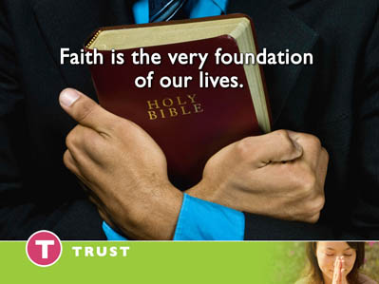  32
One modern translation of the Bible translates Hebrews 11:1 this way, “But faith forms a solid ground for what is hoped for,” (Berkley’s Translation) | 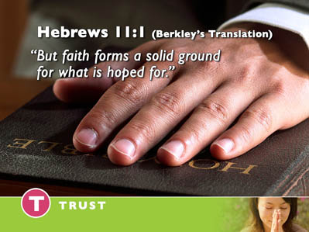  33
Another translation puts it this way, “Now faith is the confident assurance of that for which we hope....” (Weymouth’s Translation) | 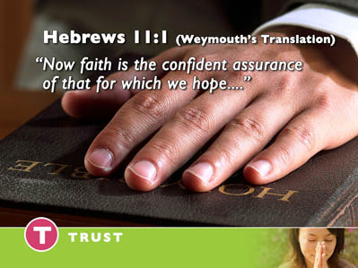  34
Faith is the North Star of our lives giving us direction. It is the light which lights our way. | 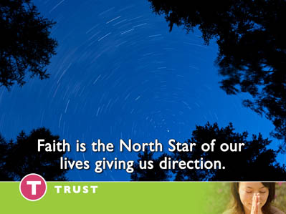  35
It is the assurance that ultimately God will fulfill all of our dreams. Faith stands under everything else. Faith supports all of our hopes. | 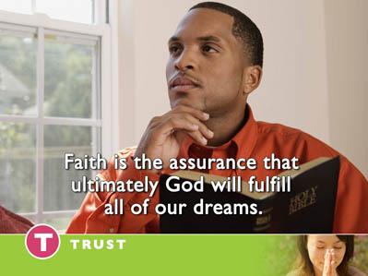  36
Faith sustains us in the perplexing questions of life. | 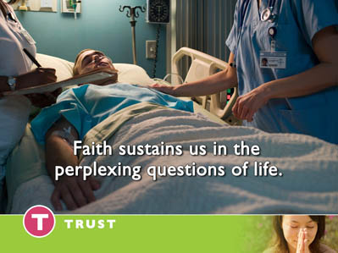  37
Faith is the essence of spiritual life which keeps it from crumbling. Abel, Enoch, Noah, Abraham, Jacob, Moses, Joseph and the other hero’s of Hebrews 11 had one thing in common – FAITH – A faith that sustained and supported them throughout their lives. They lived lives of trust.  Let’s define faith. | 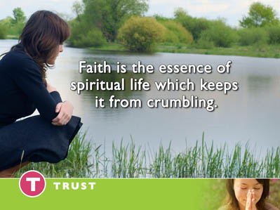  38
WHAT IS FAITH? | 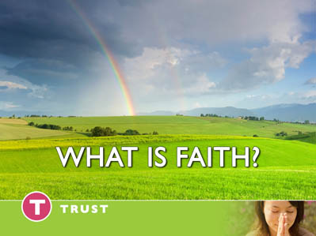  39
Faith is a relationship with God as a friend well known which leads us to do whatever He asks and accepts whatever He allows with the absolute assurance that He only wants the best for our lives. Faith believes God will strengthen us to triumph over every difficulty and over come every obstacle until the day when we receive our final reward in His eternal kingdom. | 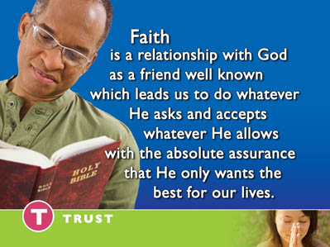  40
One of my favorite authors stated it succinctly,  “Faith is trusting God – believing that He loves us and knows what is for our good.” Education page 253  Faith energizes our entire being. Faith lifts our spirits. Faith encourages our hearts. Faith renews our hope. Faith lifts our vision from what is to what can be. Faith believes God’s promises and receives God’s gifts before they are realized. | 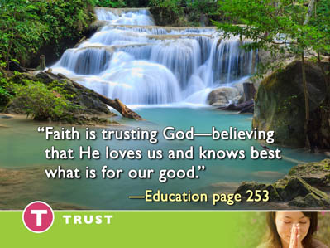  41
In Hebrews 11.  God lists the hero’s of faith down through the ages. Their names hang high in heaven’s ‘Hall of Fame’. A casual look at Hebrews 11 leaves us baffled. On the surface it’s rather confusing. It leaves us with more questions than answers. Let me give you just a few examples. Follow me as we take a brief journey through Hebrews 11 and examine the results of the faith of these champions in heavens ‘Hall of fame’.  HEAVEN’S HALL OF FAME  It is surprising that the first example of faith that God gives in Hebrews chapter 11 is of a person who dies and does not live. There is no miraculous deliverance here. | 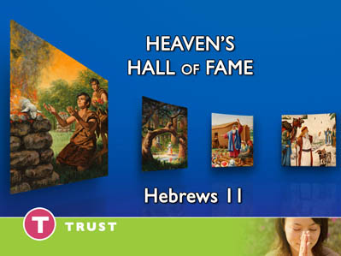  42
Let’s read the fourth verse of chapter 11. “By faith Abel offered to God a more excellent sacrifice than Cain, through which he obtained witness that he was righteous, God testifying of his gifts and though he being dead still speaks.”  According to the Bible Abel was a righteous man and what was the result of his faith? It got him killed. If he didn’t have faith, he would have lived. | 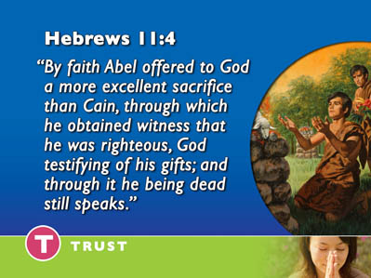  43
Cain did not have faith and he lived. Abel had faith and he died. This may seem strange to some people who have a mistaken understanding of genuine faith. They believe that if you have enough faith you will always be healed. | 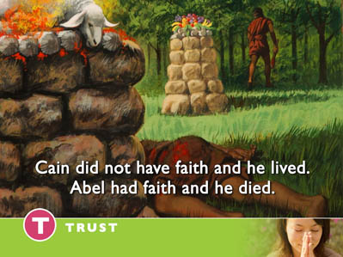  44
Now, let’s consider Enoch the next in this royal line of faith.  “By faith Enoch was translated so he did not see death, and was not found because God had translated him, for before his translation he had this testimony that he pleased God.”  (Hebrews 11:5) | 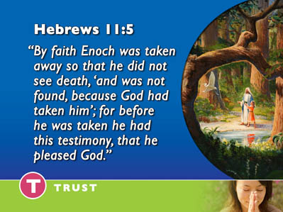  45
If Enoch didn’t have faith he would have died. Enoch has faith and he lives but Abel has the same quality of faith and he dies.  Throughout Hebrews chapter 11 each of these worthies of faith teach us how to trust God. Enoch trusts him in life and Abel trusts him in death. | 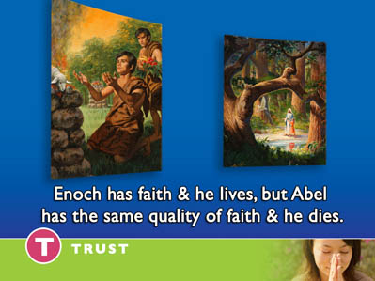  46
Let’s look at the contrast between Noah and Abraham. | 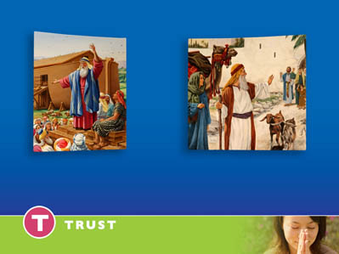  47
“By faith Noah being divinely warned of things not yet seen, moved with godly fear, and prepared an ark for the saving of His household.” (Hebrews 11:7)  Noah’s faith led him to do just what God said even though to the majority of people in his day it must have seemed ridiculous. Noah obediently followed God’s instructions. He trusted God. | 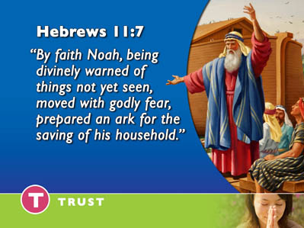  48
He remained where he was for 120 years building an ark in spite of the fact that there was no rain. Now, that’s faith. | 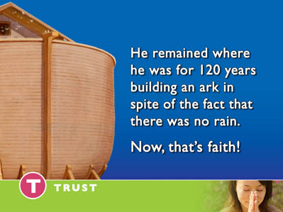  49
Abraham’s experience is just the opposite.  “By faith Abraham obeyed when he was called to go out to the place which he would afterward receive as an inheritance. And he went out not knowing where he was going.” (Hebrews 11:8)  Abraham’s faith led him to leave the security of his homeland and venture out into the unknown. | 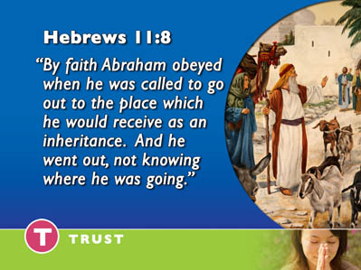  50
What contrasts. Abel died by faith and Enoch survived by faith. Noah stayed by faith and Abraham ventured out by faith.  The contrasts continue all through the chapter. | 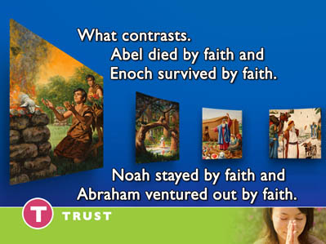  51
Sarah conceived a child by faith when she was eighty years old and years later Abraham took the child, Isaac to Mount Moriah at God’s command to sacrifice him . | 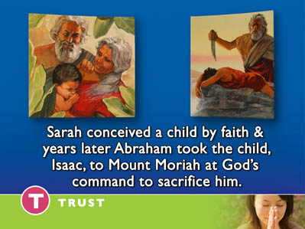  52
God honored Abraham’s faith and delivered the child. The same God who asked these parents to believe He would give them a child asked them to believe when he commanded them to sacrifice the child. | 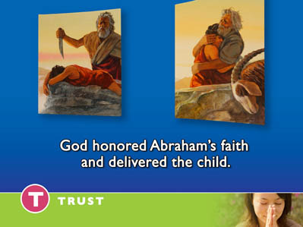  53
Here’s another contrast found in the chapter. Joseph was faithful to God in spite of the difficult circumstances of his life. Joseph came from a dysfunctional family. His jealous brothers sold him into slavery.  He was purchased by one of Egypt’s most powerful men, an officer in the Egyptian army, the captain of Pharaoh’s guard. As a faithful servant his master’s house, Joseph was given jurisdiction over all this wealthy noblemen possessed until his master’s wife made improper advances. She then blamed Joseph when he refused her seductions. | 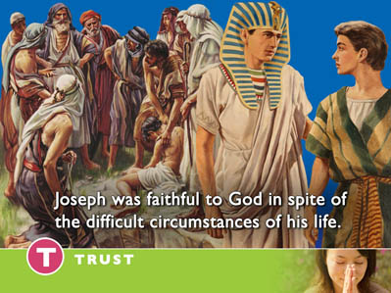  54
Falsely accused Joseph was thrown into prison. After miraculously interpreting the dreams of the royal baker and butler, Joseph ended up as the Administrative Assistant to Pharaoh. | 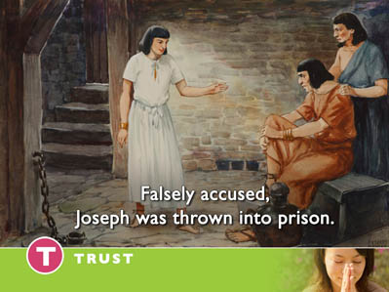  55
As the result of his faith and faithfulness God honored Joseph. He lived as a witness of the true God in Egypt among its wealth and opulence. Moses had the opposite experience. God led him out of Egypt to wander in the wilderness in total dependence on God. | 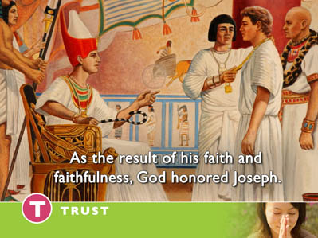  56
Moses “chose to suffer affliction with the people of God than to enjoy the pleasures of sin, esteeming the reproach of Christ greater than the treasures in Egypt; for he looked to the reward.” (Hebrews 11: 25, 26) | 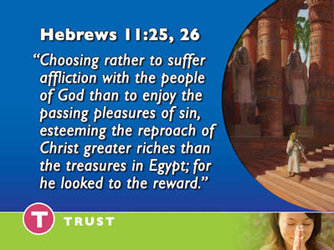  57
Joseph had faith and remained in Egypt while Moses had faith and God led him out of Egypt. | 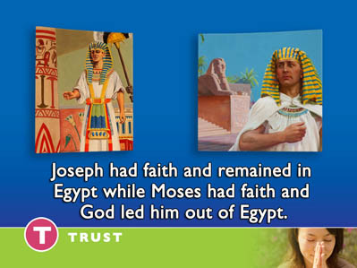  58
Through faith Joseph became rich and Moses became poor. | 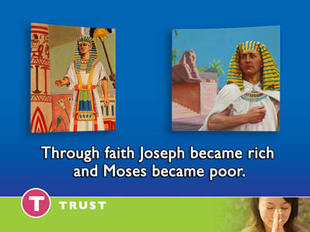  59
Are you beginning to see faith is not telling God what I want and believing He will give it to me. Faith is seeking God’s will for my life whether it is death like Abel or life like Enoch. Whether it’s staying like Noah or moving like Abraham. Whether it is living in the luxury of Egypt like Joseph or being a homeless wanderer in the desert like Moses. | 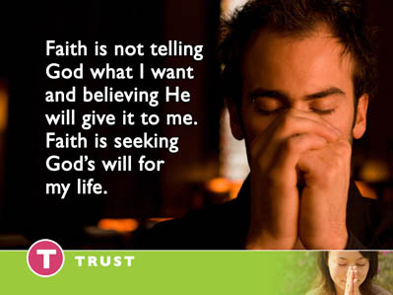  60
Faith is an abiding trust in God.  I don’t know what circumstance you may find yourself in today. You may be facing a life threatening illness or enjoying good health. You may be perfectly content in your home or facing a move and dreading it. You may be prospering financially or you may be struggling to pay your mortgage. You may be enjoying a great marriage or the relationship may be strained. You may feel very close to God or you may feel distant from Him. | 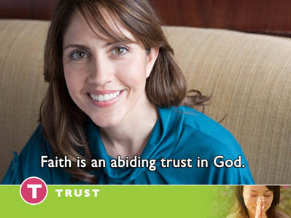  61
Faith is not dependent on our feelings. It is not dependent on our circumstances. Each of the hero’s in God’s hall of fame in Hebrews 11 went through different circumstances in their lives. Faith is not dependent on what is going on around us. It has everything to do with what is going on inside us. | 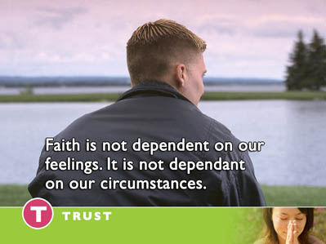  62
Each of the worthies of faith in Hebrews 11 had one common thread running through their lives. They trusted God. The common denominator is trust. Trusting God enough to believe His promises and do just what He says. Faith is not something we merely understand in our mind .Faith is something we live by. | 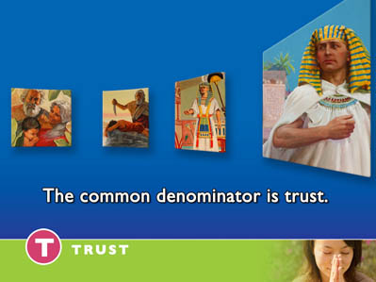  63
This is why the apostle Paul declared, “The just shall live by faith.”(Romans 1:17) | 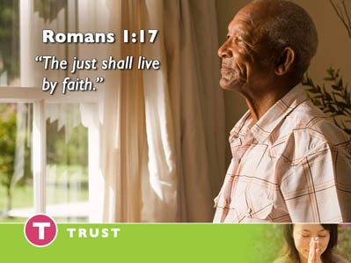  64
Faith is active not passive. It is the dynamic force in our lives that propels us forward with confident assurance. Faith believes exactly what God says and acts upon it. Faith is living a life of trust. Faith is Abel offering his sacrifice. Faith is Enoch walking with God. Faith is Noah building the boat. Faith is Abraham saying goodbye and leaving his home. Faith is Abraham’s willingness to offer up Isaac believing God will raise him from the dead if necessary. Faith is Jacob believing in his wayward sons and blessing them in death. Faith is Moses forsaking the pleasures of Egypt. Faith is Joshua marching around Jericho. | 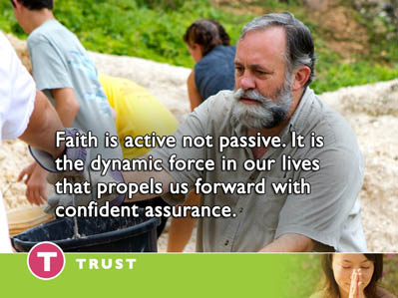  65
Faith is God’s heroes “stoned, sawn in two, slain with the sword, ...destitute, afflicted tormented, wandering in deserts and mountains…” (Hebrews 11:37) and crying out from the depths of their hearts, “God I trust you.” Faith is filled with hope and optimism because it trusts God. Faith believes God always has the best good for His children in mind. | 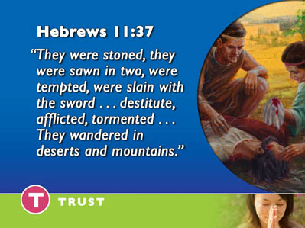  66
Faith is trusting God for:  - Strength in our weakness  - Wisdom in our ignorance  - Courage in our fear  - Peace in our anxiety  - Hope in our depression  - Guidance in our doubt  - Joy in our sorrow | 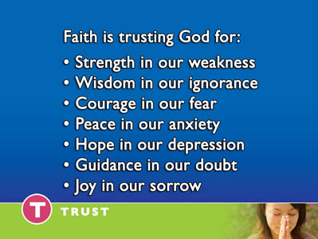  67
Faith does not know defeat. It does not understand the word – IMPOSSIBLE – It is filled with courage. | 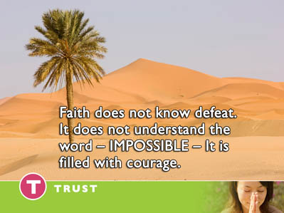  68
Faith trusts God in all of life’s circumstances. | 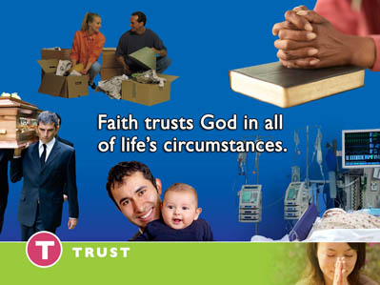  69
The story is told of Hiram Judson the great missionary to the Orient. Judson had been arrested for his preaching and was lying bound in chains in a hot, filthy Burmese prison; His feet were shackled in iron manacles to a bamboo pole. The prospects for future success in reaching people with the gospel looked grim. | 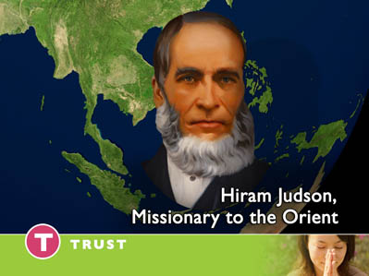  70
With a sneer on his face, a fellow prisoner cynically asked, "Dr. Judson, what about the prospect of the conversion of the heathen now? Judson’s instant reply was, "The prospects are just as bright as the promises of God." The humble missionary’s faith soared beyond his challenging circumstances to the all powerful promises of God.  What journey of faith has He asked you to step out on?  What pilgrimage has He asked you to make? Faith is trusting God on the journey he is leading you on through life. | 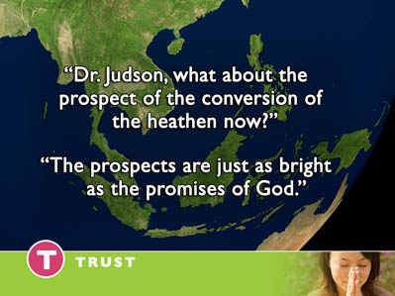  71
FAITH’S SOURCE  Faith always has a source. It is not faith in our abilities or faith in our faith – It is faith in God. Faith is not some kind of hyped up positive thinking. Faith IS not some self induced warm feeling.  Faith has a source. Hebrews chapter 11 and verse 6 describes the source of all faith. | 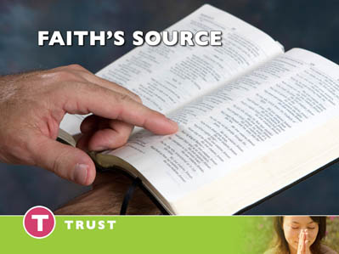  72
“But without faith it is impossible to please Him, for he who comes to God must believe that He is and He is a rewarder of those who diligently seek Him.” (Hebrews 11:6)  The source of all faith is an all-powerful, all- knowing, all-loving God. A trusting relationship with God begins with the realization that He loves us and desires only good for us. | 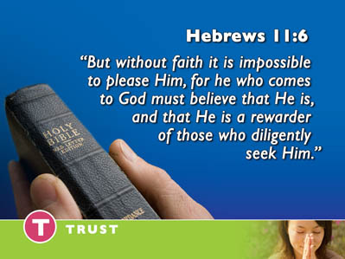  73
“For I know the plans that I have toward you,” declares the Lord, “plans to prosper you and not to harm you, plans to give you hope and a future.” (Jeremiah 29:11) | 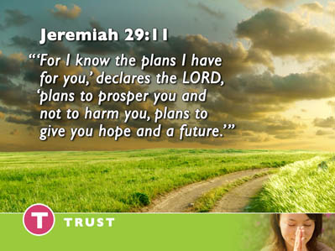  74
Des Cummings, PH.D, Executive Vice President for Florida Hospital puts it this way, “God’s love is the key that unlocks human potential. His love transforms our lives. It empowers us to rise above our challenges and this love helps to heal our wounds.” (Creation Health Seminar Workbook, pg 135) | 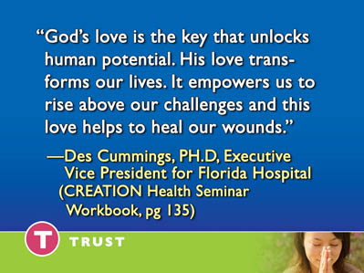  75
Dr. Bernie Siegel, A physician at Yale University affirms the amazing power of love in his best selling book, Love, Medicine and Miracles.  “Unconditional love is the most powerful stimulant of the immune system. The truth is love heals.” (Love, Medicine and Miracles, pg 181)  Our faith leads us into a relationship of trust with an all knowing Creator who loves us unconditionally. | 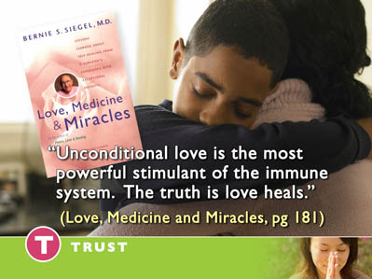  76
By faith, as Moses, we “endure as seeing Him who is invisible.” (Hebrews 11:27)  How do we see some thing which is invisible? By definition something invisible is something you do not see. We see it by faith. Faith grasps the reality of God’s presence. | 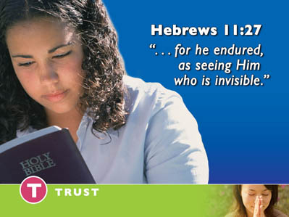  77
Dietrich Bonheoffer remained faithful to God during Hitler’s Third Reich in Germany. This godly pastor clung to his faith at any cost. He was cast into prison. German towns were being continuously bombed by the Allied Forces In his memoirs. Dietrich Bonheoffer describes his feelings as the prison he was being held in shook. In the midst of one of these intense bombing attacks he wrote, | 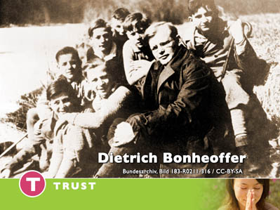  78
“I sensed the presence of God.” On the brink of death in a German prison camp Dietrich Bonheoffer sensed the presence of God. His faith soared beyond what was to what would be. It looked beyond his life threatening condition to a loving God who had better plans in mind for him. | 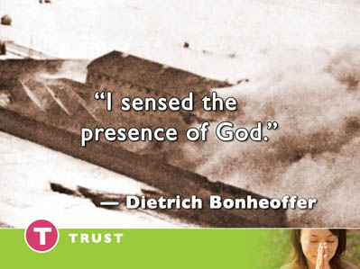  79
INCREASING OUR FAITH  What do you do when your faith is weak? You may be thinking, “That’s just my problem” I don’t have much faith. I have some good news for you. You have more faith than you realize | 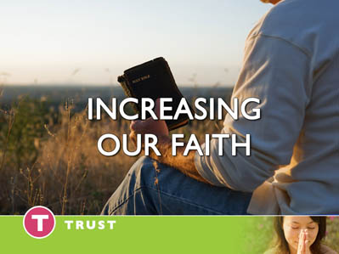  80
The problem is not you do not have any faith. The problem is you have not exercised the faith you have. | 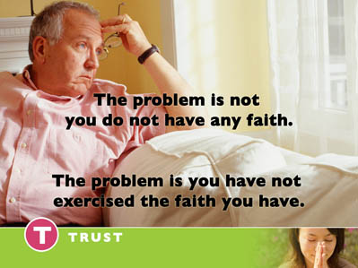  81
Listen to the Paul’s words in Romans 12:3 “As God has dealt to each one a measure of faith.” When we make a conscious choice to reach out to this all-loving, all-powerful God and trust Him, He places within our hearts a measure of faith. | 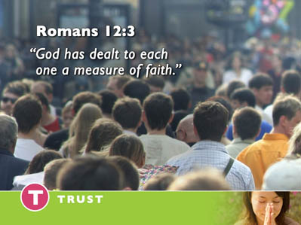  82
Faith is a gift that God gives us. The more we exercise that gift the more it will grow. | 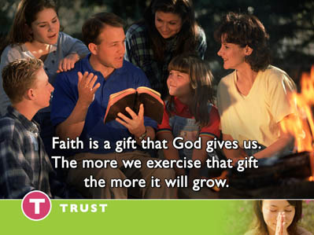  83
Faith grows as we learn to trust God in the trials and challenges we face in life. There are times in our lives when faith grows in the most difficult circumstances of life. Sometimes our moments of greatest desperation are moments of greatest ‘faith growth. | 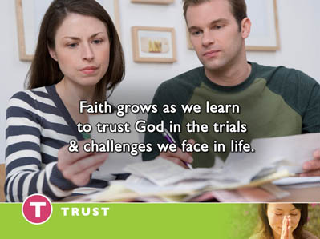  84
Our faith also grows as we meditate upon God’s Word. As the truths of the Bible fill our minds, our faith grows rapidly. The scripture affirms this divine reality in Paul’s letter to the Romans. | 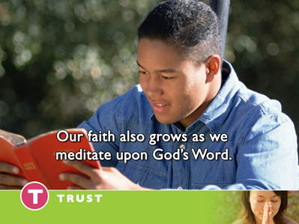  85
“So faith comes by hearing and hearing by the Word of God.” (Romans 10:17) The more we fill of minds with God’s Word, the more our faith will increase. His Word dispels our doubts. | 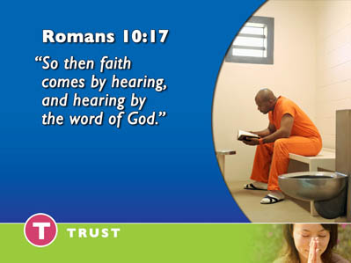  86
The late Dr. Howard A. Kelly was professor of gynecology at Johns Hopkins University. He held honorary degrees from the Universities of Pennsylvania, Washington and Lee, Aberdeen and Edinburgh. He was one of the four great men who made Johns Hopkins famous and he was a pioneer in the field of gynecology and radium therapy, as well as in the field of medical illustrations. His published works were unsurpassed in his day. Here is his remarkable statement of faith, | 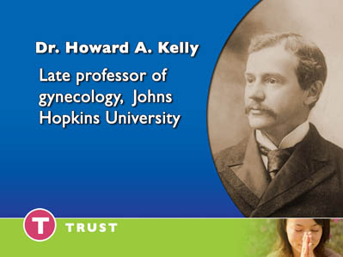  87
“I have within the past forty years of my life come out of uncertainty and doubt into a faith which is an absolutely dominating conviction of the Truth, and about which I have not a shadow of doubt.” How did this occur?  What led this eminent Physician and researcher from doubt to faith? What led him out of his spiritual confusion? Listen to his testimony, | 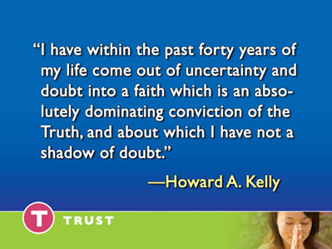  88
“At last it occurred to me to see what the Book had to say about itself... I then tried the natural plan of using it alone as my textbook of religion as I would take a textbook in any science, testing it by submitting to its conditions, as Christ Himself invites men to do. (John 7:17). | 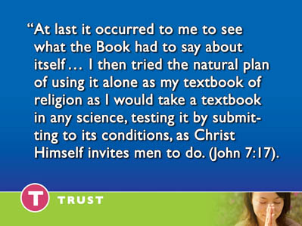  89
As a result I now believe the Bible to be the inspired word of God, inspired in a sense utterly different from that of any merely human book.... I find it to be a consistent and wonderful revelation, from Genesis to Revelation, of the character of God, far removed from any man's natural imaginings. | 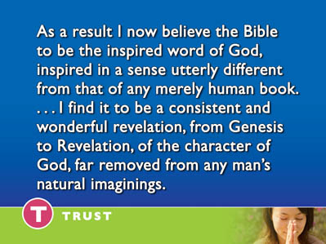  90
It also reveals a tenderness and nearness of God in Christ that satisfies the heart's yearnings and presents the infinite God, Creator of the world, as taking our very nature upon Him in infinite love to become one of His people in order to redeem them.” | 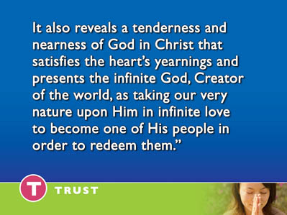  91
As Dr. Kelley filled his mind with God’s Word, his faith increased. He declared, “I place no limits to a faith vested in God as the sum of all wisdom and knowledge and trust Him though standing alone before the world in declaring Him to be true.” | 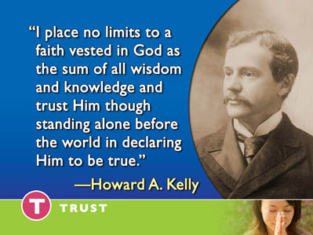  92
You too can have this life changing faith. Your faith will grow as you come in contact with the powerfully transforming principles of God’s Word. I suggest that you begin by setting aside some time every day to read the gospels. | 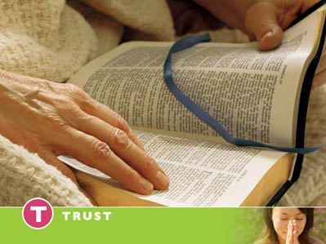  93
As in your imagination you walk with Jesus down the cobbled stone streets of Jerusalem— | 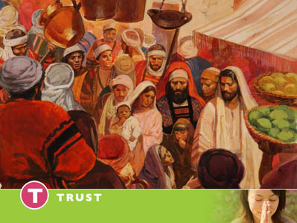  94
—And the dusty pathways of the Galilee your faith will soar. | 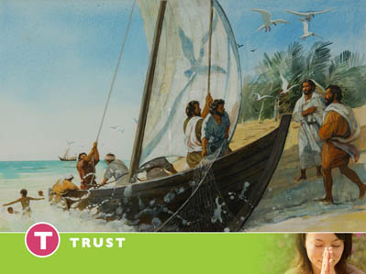  95
As you relive His parables and miracles, your love for Him will increase. | 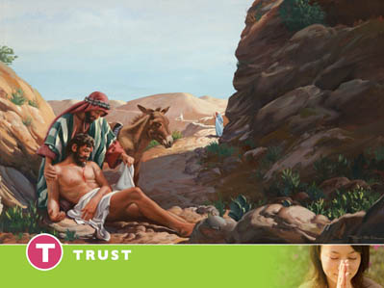  96
As you watch as he heals the sick, casts out demons and raises the dead, you will stand amazed, but most of all your love for Him will deepen as you listen to His Words of forgiveness and tender compassion. | 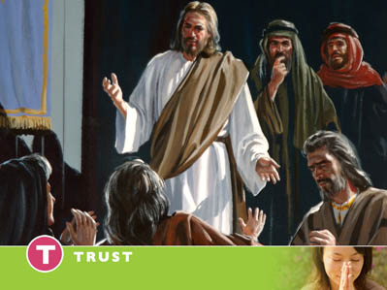  97
AMAZING FAITH IN THE 20th CENTURY – ELIZABETH ELLIOT  One of the amazing stories of faith in the 20th century is the story of Elizabeth Elliot .Elizabeth’s husband Jim was speared to death by the Auca Indians on January 3, 1956 on the Curaray River in Ecuador. Some considered the Auca’s the most savage tribe on earth. | 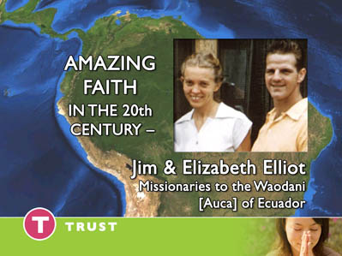  98
The five missionaries made repeated attempts to contact the Auca’s. They flew over their village. They dropped gifts from the aid. All seemed to be going well. The barriers seemed to be breaking down. They felt it was safe to land. They landed their small plane on a small river bed landing strip and set up base camp. |   99
Each day they made contact by radio with their wives at another mission station. Then there was silence. They simply didn’t call on the radio. For five long terrible days of uncertainty five women and the missionaries’ children waited for word. Then two bodies were sighted from the air. During this time of uncertainty Elizabeth Elliot wrote this letter to her parents. | 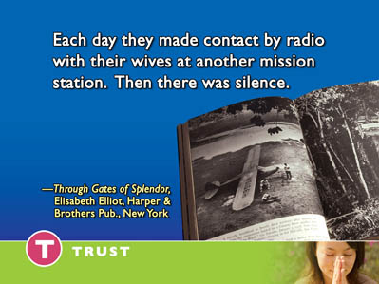  100
“I want you to know that your prayers are being answered moment by moment regarding me. I am ever so conscious of His everlasting arms.  “I have no idea what I will do for Him if Jim is dead but the Lord knows and I am at rest.” | 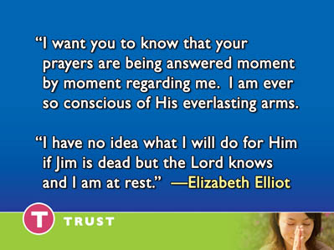  101
When word came that all five were dead, the women and children gathered to comfort one another and pray.  One of the ladies went to the piano and began to play the song they all sang together the morning the men left on their journey. | 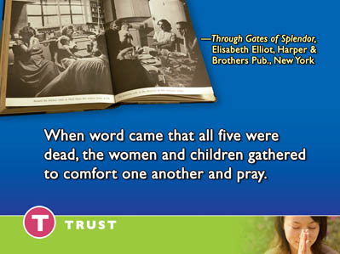  102
“We rest on thee our shield and defender. We go not forth along against the foe. Strong in thy strength, safe in thy keeping tender.  We rest on thee and in thy name we go.” | 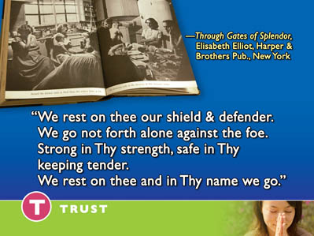  103
Fast forward a few years. Elizabeth Elliot commits her life in faith to reach the Auca’s  God miraculously opens the door and this amazing woman of faith enters the Auca village and lives among them.  She wrote “Faith must embrace doubt. Nothing less than faith could have brought us to Aucaland.”  God opened the door to one of the most savage tribes on earth.  Fast Forward Again. | 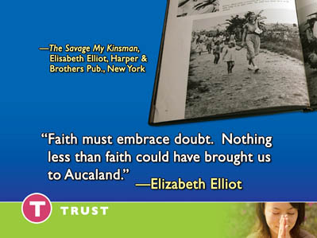  104
It is a sunny day in the Ecuadorian jungles, the sky is blue, and the river’s water clear.  Time has passed. The Auca’s have accepted the gospel. One of their own has become an ordained pastor.  He now steps into the water to baptize Kathy Saint. Years before he had speared her father to death on the banks of the same river. | 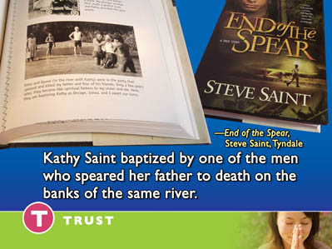  105
- Faith has triumphed over every obstacle.  - Faith has reached out and clasped the hand of God in crisis.  - Faith has become a channel for God’s power to reach the Auca’s | 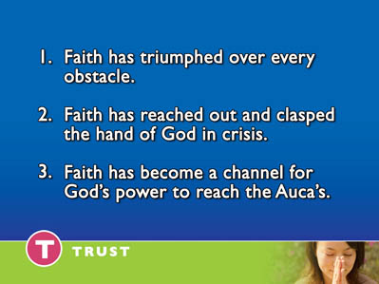  106
Would you like to open your heart to God and by faith receive His power today? Would you like to enter into a new relationship of trust and confidence in God? Would you like to bow you head with me right now and place your life in His hands.? | 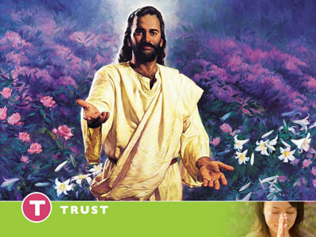  107

